16 Days of Activism social media Kit – 2022
Acknowledge. Heal. Reimagine.
This year, as we acknowledge the impact of COVID-19 and other global crises on us as individuals and collectively, we hope to collectively heal together and center ourselves to re-imagine what feminist futures can look like.
To support our collective re-imagination and activism through the 16 Days of Activism, this social media Kit provides a few graphics and text we can use on our social media platform. You can just copy and paste to your different social media platforms. You can access more of these Social Media Memes here. Feel free to download and make your own captions too!
Don’t forget to tag @GBVnet on Twitter, @GBVPreventionNetwork on Facebook and @preventgbvnet on Instagram, we will share and amplify whatever you share with us. We will be using the hashtags; #16DaysOfActivism and #AcknowledgeHealReimagine.

No. | Text | Image
 | This #16DaysOfActivism we are going to acknowledge all the changes that have happened, collectively heal together and re-imagine new feminist realities. #AcknowledgeHealReimagine | 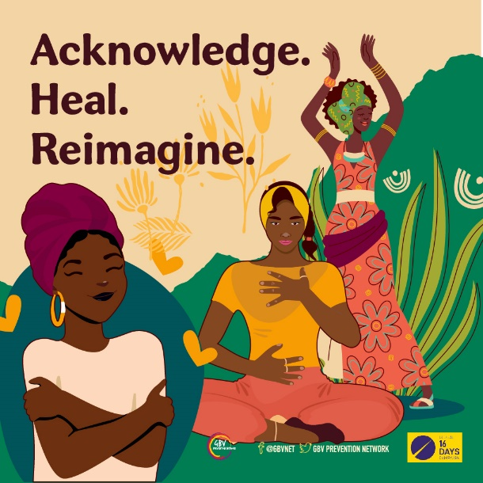
 | What if we could make the world just, equal and better for everyone? A better world is possible. #16DaysOfActivism #AcknowledgeHealReimagine | 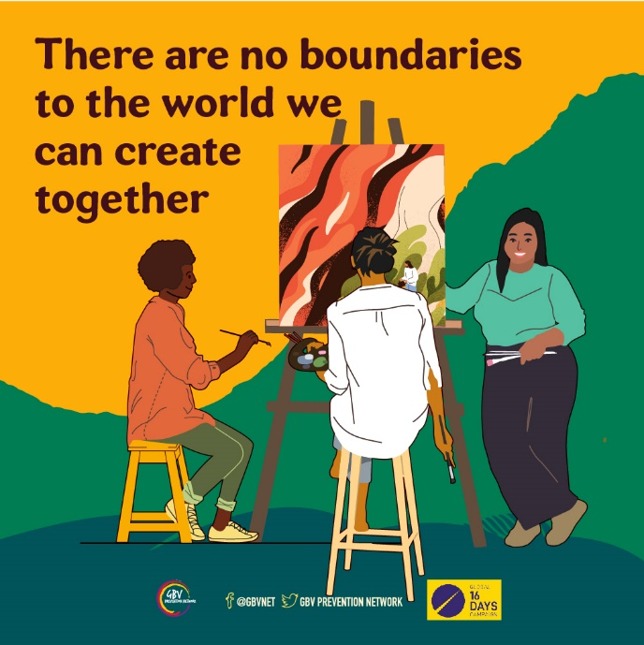
 | We are re-imagining a world that is free from all forms of discrimination, inequalities and -isms. We can co-create a world that includes everyone. #16DaysOfActivism #AcknowledgeHealReimagine | 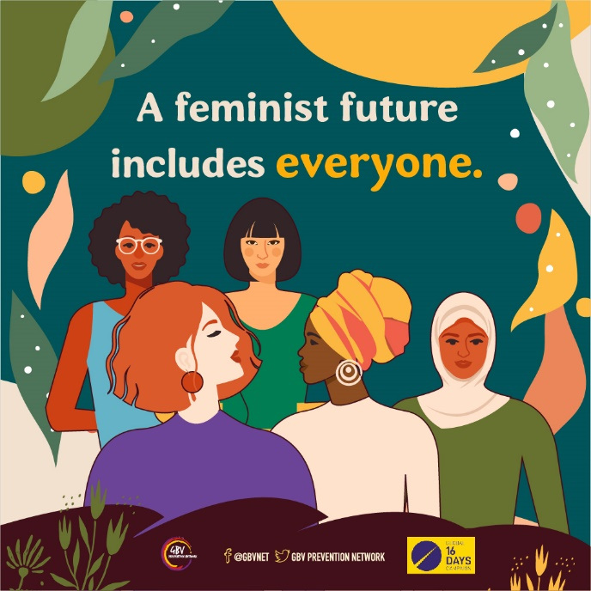
 | Rest is not a privilege; it is a right and passage to social justice. Feminist realities reimagine how we envision and experience rest. Dismantling the grind culture and how capitalism views us as tool. #16DaysOfActivism | 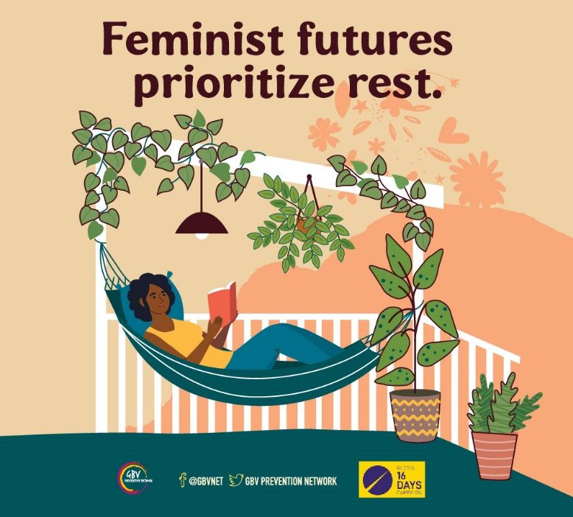
 | Feminists across the world have and continue to work tirelessly to build a better world. So much has been changed and a new world is on the horizon. #16DaysOfActivism #AcknowledgeHealReimagine | 